Schaan, Oktober 20th 2022
Media release about the final event of Youth Alpine Interrail

Flexible and eco-friendly through the Alps
The right decision for their wallet and for the environment: 150 young participants in CIPRA’s Youth Alpine Interrail project celebrated the end of their climate-friendly journey of discovery through the Alps by train and bus in Bern at the beginning of October 2022.
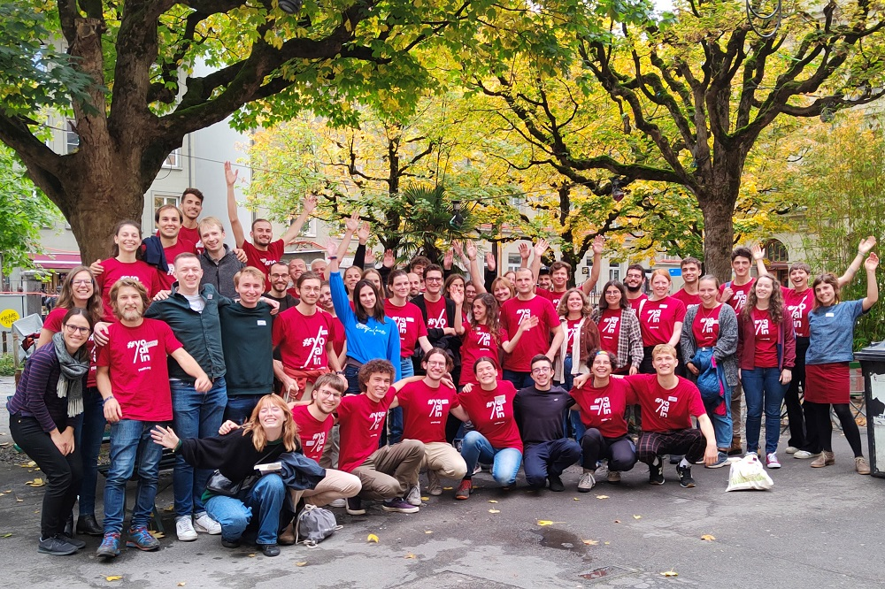
Group photo of the participants at the final event in Bern (c) CIPRA

How can I save money when travelling and protect the climate at the same time? How can I travel as flexibly as possible and still be environmentally friendly? More and more of the 120 million visitors to the Alps are asking these questions every year, not least because of skyrocketing fuel prices. This summer, 150 young people who travelled through the Alps as part of YOALIN – Youth Alpine Interrail – showed that it is possible to combine inexpensive, environmentally friendly and flexible travel.

In the Yoalin project, launched in 2018 by CIPRA International and its Youth Advisory Council (CYC), participants spend a month exploring the Alps by train with an Interrail pass – including in the summer of 2022. Many of the “Yoalins” undertook impressive mountain hikes and cycling trips between their journeys and were thus doubly climate-friendly. They also benefited from the flexibility and cross-border validity of the ticket.

More than a train ticket

The project has created an active, constantly growing Yoalin community: many former participants are now active as ambassadors for the project. They support the travellers, answer questions, give valuable travel recommendations or provide places to sleep.

This summer, the Yoalin travellers met repeatedly, for example at the end of August in Bolzano/I, to talk about a Climathon – a creative confrontation with climate change. In mid-September, more than a dozen “Yoalins” gathered in Ljubljana to get to know the city together. In Vienna, one of the funding bodies, the Austrian Climate Ministry, invited them to a talk with Minister Leonore Gewessler on 28 September. At the Climate Ministry, the travellers shared their experiences and expressed their wishes to the enthusiastic Minister.

A grand finale

Almost 60 young adults met in Bern for this year’s final event from 7 to 9 October. They got to know the city and attended workshops on the topics of climate, mobility and community. Many of them want to stay connected with Yoalin and promote environmentally friendly mobility in the Alpine region as “Yoalin Ambassadors”. “This experience was very enriching for us, especially as students of sustainable tourism! We learned a lot about the different forms of transport in the Alps. Merci for all the beautiful discoveries on our trip,” said participants Louise David and Chloé Remy.

The Swiss Federal Office for Spatial Development, which has supported Yoalin since the beginning of the project, co-organised the final event in Bern. Other important sponsors include the German Federal Ministry for the Environment, Nature Conservation, Nuclear Safety and Consumer Protection (BMUV) and ARGE ALP.
(2,659 Characters including spaces)

This release and print-ready photographs are available for downloading from http://www.cipra.org/en/press/press-releases

Further Information:
Caroline Begle, Head of Communications, CIPRA International, +423 237 53 53, caroline.begle@cipra.org

CIPRA, for a good life in the Alps
CIPRA, the International Commission for the Protection of the Alps, is a non-governmental umbrella organisation with national representatives and one regional representative in the seven Alpine countries. It represents more than 100 associations and organisations. CIPRA works towards achieving sustainable development in the Alps; it also strives to preserve the natural and cultural heritage, maintain regional diversity, and bring about solutions to cross-border problems in the Alpine region. www.cipra.org

