Brig, October 27, 2022
Media release: Alpine states adopt plan for climate-neutral Alpine transport
Alliance for climate-neutral Alpine transport
Seven of eight signatory states to the Alpine Convention today signed a progressive action plan for climate-neutral mobility by 2050 in Brig/CH. CIPRA International contributed to the almost two-year development of the action plan with proposals for the “Simplon Alliance”. CIPRA and the Alpine Initiative are calling for more than mere lip service to the alliance.
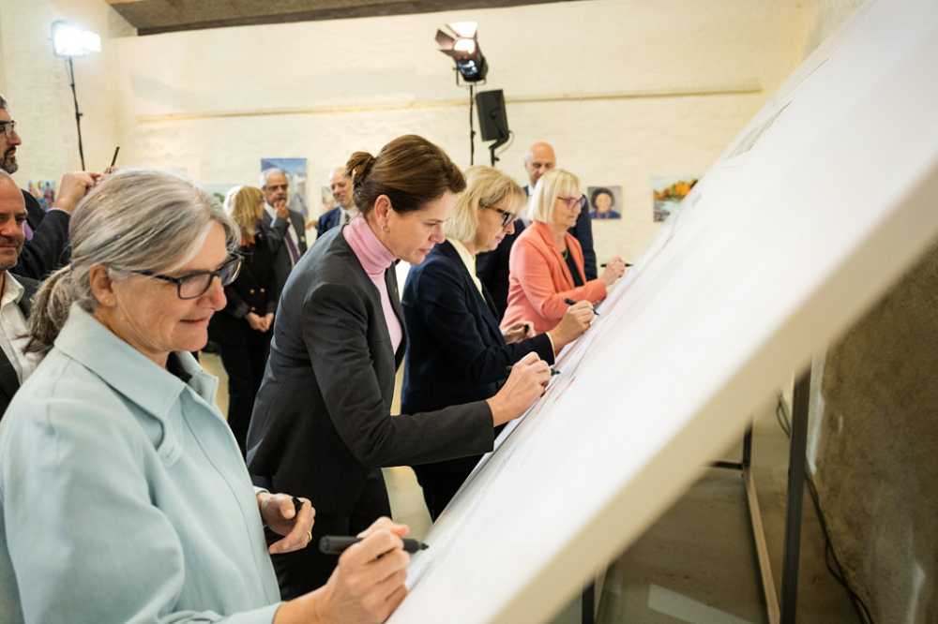
Representatives of the environment and transport ministries of the Alpine countries sign the action plan for climate-neutral transport by 2050. © David Schweizer, ARE

On October 27, 2022, the “Simplon Alliance” was launched in Brig/CH, an action plan signed by the environment and transport ministries of the Alpine countries. The fact that “transport is one of the largest emitters of greenhouse gases in the Alpine region, accounting for almost 30% of all greenhouse gas emissions”, as it states in its introduction, shows that the problems are manifold. The document signed in Brig pursues the goal of “making mobility in the Alpine region climate-neutral and climate-resilient by 2050”.
Just how challenging this will be to achieve is shown by the extensive catalogue of measures that covers the areas of freight transit, passenger traffic and leisure mobility and is committed to the motto “avoid – shift – improve”. With regard to traffic reduction, the focus is on incentives and education, i.e. the voluntary participation of transport users.

Freight transport: more trucks on the rails
In terms of the modal shift, the focus is on transalpine freight transit traffic. Here, the standout commitment is to avoiding empty truck journeys. The originally envisaged joint capacity management in the Alpine transit corridors was watered down to "joint coordination". There is thus still no clear commitment to the fullest possible internalisation of the external costs of road freight transport in the implementation of the EU infrastructure costs directive in the relevant countries. It would also have been desirable to have an assurance that regional special toll surcharges levied by individual countries could not be blocked by other Alpine corridor countries.

Passenger transport: encouraging commuters to change trains
Public transport on road and rail is to be decarbonised and slow traffic is to be promoted. To get the huge flows of commuters in the main valleys of the Alpine regions away from the motorways, a cross-border, flexible public transport ticket valid throughout the Alps should be created. The CIPRA Youth Advisory Council has been campaigning for such an “AlpTick” for six years now: at the XVIIth Alpine Conference of the Alpine Convention, held in Brig on the same day, it called for the country representatives to lend concrete support to its cause.

Leisure mobility: holidays without traffic jams
In order to cope with the massive traffic jams that congest the Alpine motorways every summer and winter, burdening local people with noise, exhaust fumes and particulate matter, the Alpine countries have committed themselves to a comprehensive set of promotional measures. Tourist destinations are to be better connected by public transport, climate-neutral travel in connection with comprehensive tourist offers is to be enabled and promoted, while local hiking and biking offers are to be boosted with regional master plans and investment programmes.

The Simplon Alliance: non-binding in nature
CIPRA International contributed to the almost two-year development of the action plan for the Simplon Alliance with proposals and expertise. Kaspar Schuler, CIPRA’s Executive Director, has mixed feelings about the final product: “The measures are impressively contemporary. However, to get them ready for signature they have been formulated in a very woolly way. Two cornerstones that we had demanded are missing altogether: an Alpine-wide commitment to a ban on the transport of hazardous goods on the most important Alpine crossings, which only exists in Switzerland. And an implementation plan with clearly defined tasks and milestones. Both must continue to be demanded – so that life in the Alps is not suffocated by traffic jams.”
(3,759 Characters including spaces)

Further information on the Simplon Alliance: www.are.admin.ch/simplon-allianz (de, fr, it, en)

This press release and printable press photos are available for download at: https://www.cipra.org/en/media-releases
Inquiries should be directed to:
Kaspar Schuler, Managing Director CIPRA International, +423 79 300 55, kaspar.schuler@cipra.org

CIPRA, for a good life in the Alps
CIPRA, the International Commission for the Protection of the Alps, is a non-governmental umbrella organisation with national representatives and one regional representative in the seven Alpine countries. It represents more than 100 associations and organisations. CIPRA works towards achieving sustainable development in the Alps; it also strives to preserve the natural and cultural heritage, maintain regional diversity, and bring about solutions to cross-border problems in the Alpine region. www.cipra.org

Austria, France, Germany, Liechtenstein, Monaco, Slovenia, Switzerland. Italy's signature is currently pending due to the newly elected government. (Status: 27.10.2022)

